FUNDAMENTOS DE REDES DE DADOS E COMUNICACÃO

A topologia de redes propostas para as três unidades pode ser vista na figura a baixo.

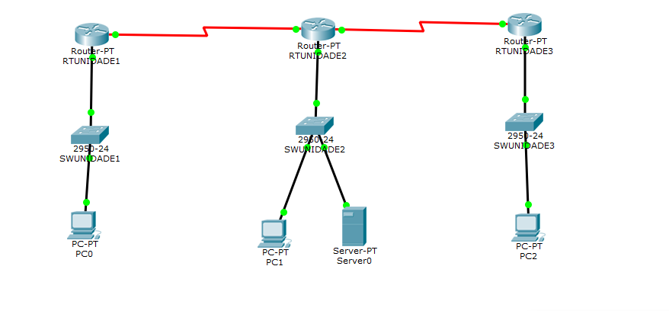

**Configuracão dos Roteadores utilizados.**

**RTUNIDADE1**

Current configuration : 880 bytes  
!  
Version 12.2  
no service timestamps log datetime msec  
no service timestamps debug datetime msec  
!  
hostname RTUNIDADE1  
!  
!  
!  
enable secret 5 $1$mERr$xFtoEReOUoqxdvKDpSAhc/  
!  
!  
!  
!  
!  
!  
ip cef  
no ipv6 cef  
!  
!  
!  
!  
!  
!  
!  
!  
!  
!  
!  
interface FastEthernet0/0  
 ip address 192.168.1.1 255.255.255.0  
 duplex auto  
 speed auto  
!  
interface FastEthernet1/0  
 no ip address  
 duplex auto  
 speed auto  
 shutdown  
!  
interface Serial12/0  
 ip address 200.1.1.2 255.255.255.0  
 clock rate 2000000  
!  
interface Serial13/0  
 no ip address  
 shutdown  
!  
interface FastEthernet4/0  
 no ip address  
 shutdown  
!  
interface FastEthernet5/0  
 no ip address  
 shutdown  
!  
router rip  
 network 192.168.1.0  
 network 200.1.1.0  
!  
ip classless  
!  
ip flow-export version 9  
!  
!  
!  
!  
!  
!  
!  
!  
line con 0  
!  
line aux 0  
!  
line vty 0 4  
 password ERICK  
 login  
!  
!  
!  
end

**RTUNIDADE2**

Current configuration : 850 bytes  
!  
Version 12.2  
no service timestamps log datetime msec  
no service timestamps debug datetime msec  
!  
hostname RTUNIDADE2  
!  
!  
!  
enable secret 5 $1$mERr$xFtoEReOUoqxdvKDpSAhc/  
!  
!  
!  
!  
!  
!  
ip cef  
no ipv6 cef  
!  
!  
!  
!  
!  
!  
!  
!  
!  
!  
!  
interface FastEthernet0/0  
 ip address 192.168.2.2 255.255.255.0  
 duplex auto  
 speed auto  
!  
interface FastEthernet1/0  
 no ip address  
 duplex auto  
 speed auto  
 shutdown  
!  
interface Serial12/0  
 ip address 201.1.1.2 255.255.255.0  
 clock rate 2000000  
!  
interface Serial13/0  
 no ip address  
 shutdown  
!  
interface FastEthernet4/0  
 no ip address  
 shutdown  
!  
interface FastEthernet5/0  
 no ip address  
 shutdown  
!  
router rip  
 network 192.168.2.0  
 network 201.1.1.2  
!  
ip classless  
!  
ip flow-export version 9  
!  
!  
!  
!  
!  
!  
!  
!  
line con 0  
!  
line aux 0  
!  
line vty 0 4  
 password ERICK  
 login  
!  
!  
!  
end

**RTUNIDADE3**

Current configuration : 830 bytes  
!  
Version 12.2  
no service timestamps log datetime msec  
no service timestamps debug datetime msec  
!  
hostname RTUNIDADE3  
!  
!  
!  
enable secret 5 $1$mERr$xFtoEReOUoqxdvKDpSAhc/  
!  
!  
!  
!  
!  
!  
ip cef  
no ipv6 cef  
!  
!  
!  
!  
!  
!  
!  
!  
!  
!  
!  
interface FastEthernet0/0  
 ip address 192.168.3.2 255.255.255.0  
 duplex auto  
 speed auto  
!  
interface FastEthernet1/0  
 no ip address  
 duplex auto  
 speed auto  
 shutdown  
!  
interface Serial12/0  
 ip address 210.1.1.2 255.255.255.0  
 clock rate 2000000  
!  
interface Serial13/0  
 no ip address  
 shutdown  
!  
interface FastEthernet4/0  
 no ip address  
 shutdown  
!  
interface FastEthernet5/0  
 no ip address  
 shutdown  
!  
router rip  
 network 192.168.3.1  
 network 210.1.1.1  
!  
ip classless  
!  
ip flow-export version 9  
!  
!  
!  
!  
!  
!  
!  
!  
line con 0  
!  
line aux 0  
!  
line vty 0 4  
 password ERICK  
 login  
!  
!  
!  
end

**Tabela de endereços IP**

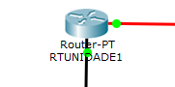 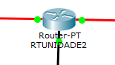 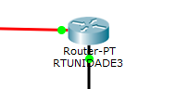

192.168.1.1 192.168.2.1 192.168.3.1

255.255.255.0 255.255.255.0 255.255.255.0

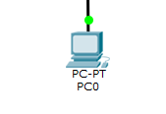 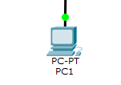 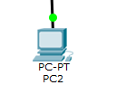

192.168.1.2 192.168.2.2 192.168.3.2

255.255.255.0 255.255.255.0 255.255.255.0  
  
  
  
 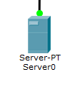

192.168.2.3